* **PROJECT NAME :**

**STORE MANAGER : KEEP TACK OF INVENTORY**

* **TEAM SIZE :4**
* **TEAM LEADER: Roobini.m**
* **TEAM MEMBERS :**
* **Prithiga.s**
* **Priyadharshini.h**
* **Praveena.m**
* **Priyangasree.p**
* **TEAM ID:NM2025TMID36363**

* **PROCEDURE:**
* Download Node.js LTS version.

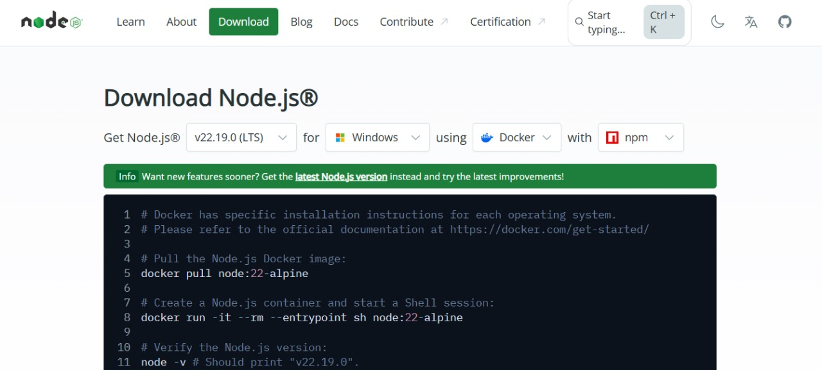

* Select your system configuration and click on (windows installer(.msi)) if windows.

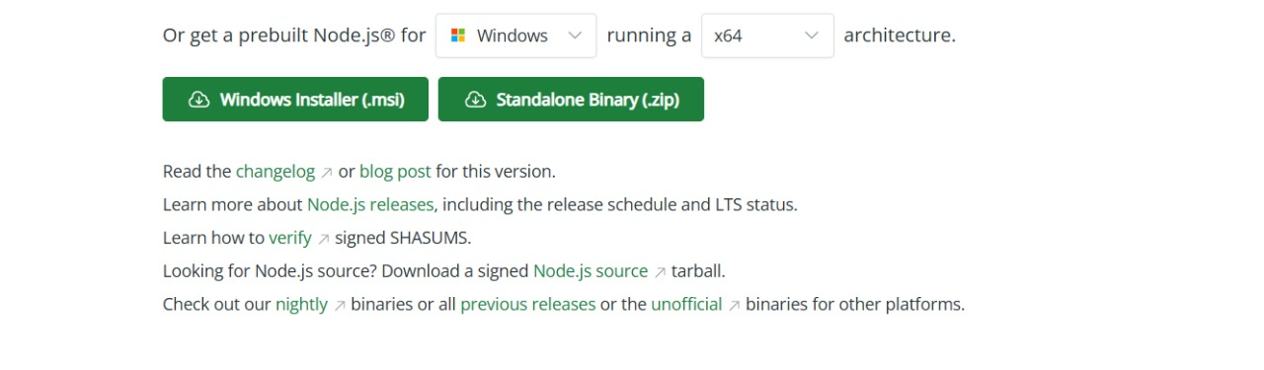

* After downloading, install Node.js by opening the downloaded file and follow the instructions below.

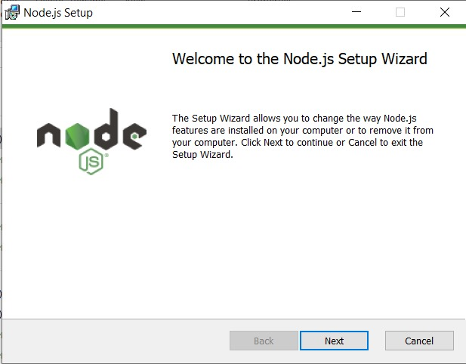

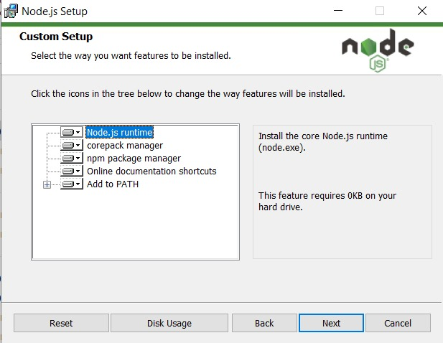

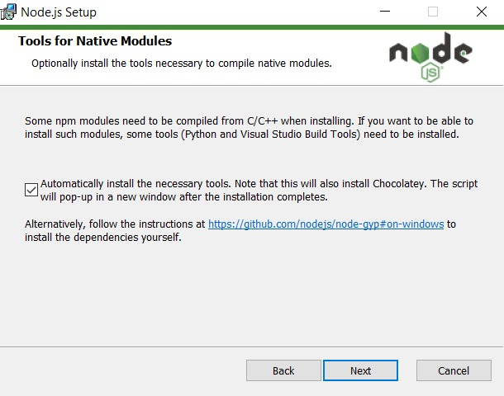

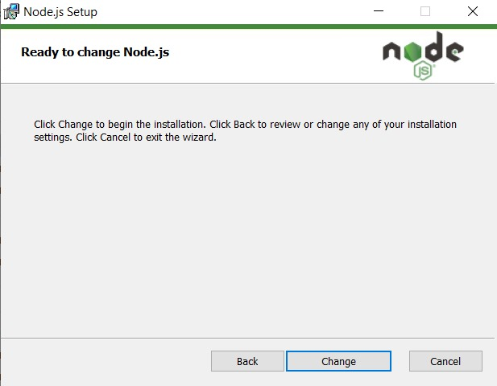

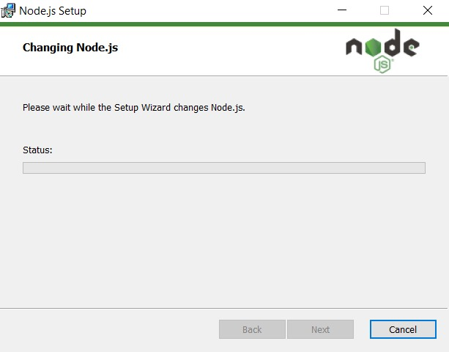

* After installing Node.js, open Windows PowerShell As Administrator

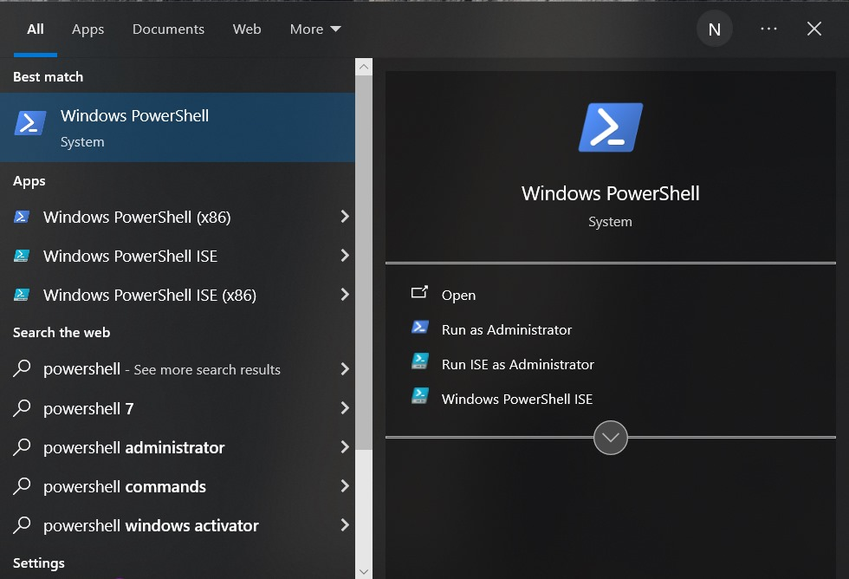

* Type set-execution policy unrestricted and press enter

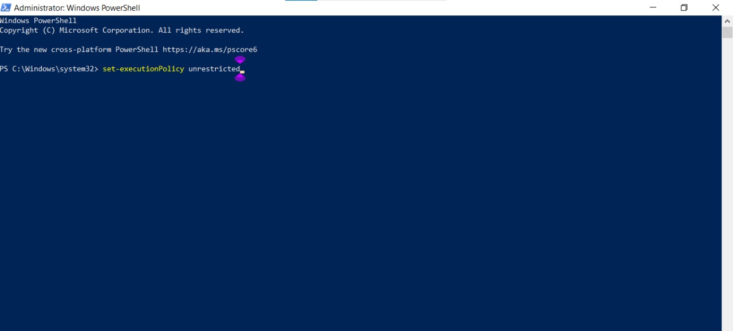

* In the next step type Y and press enter

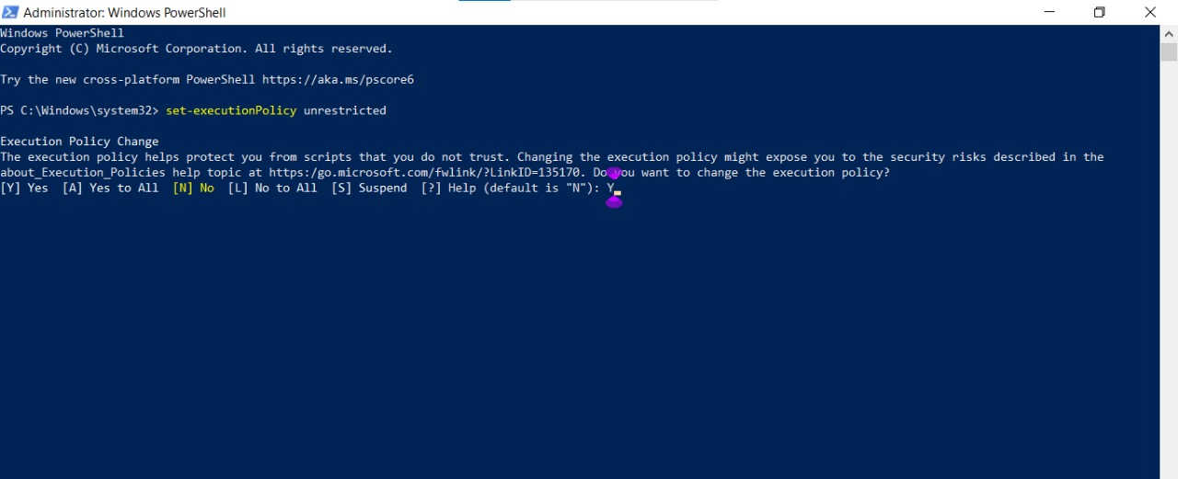

* Steps To Download and Execute Project:

* From your Smart internz portal Go to Projects → Access Resources → Guided Projects → Go to Workspace

* Inside Guided Project you can find Project Flow

* Now you can see two links one is the demo video, and the other is the code drive link.

* Click on the code drive link or copy paste that link in your new chrome tab.

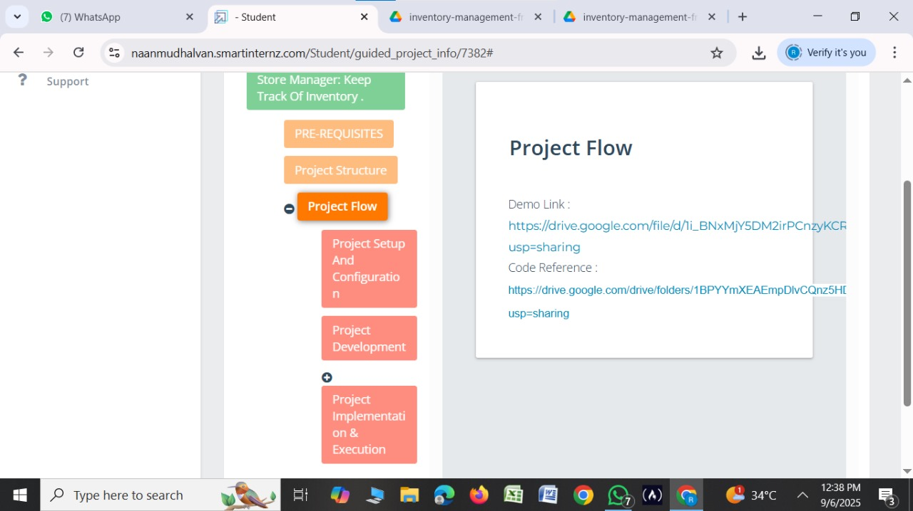

* Download the the code folder

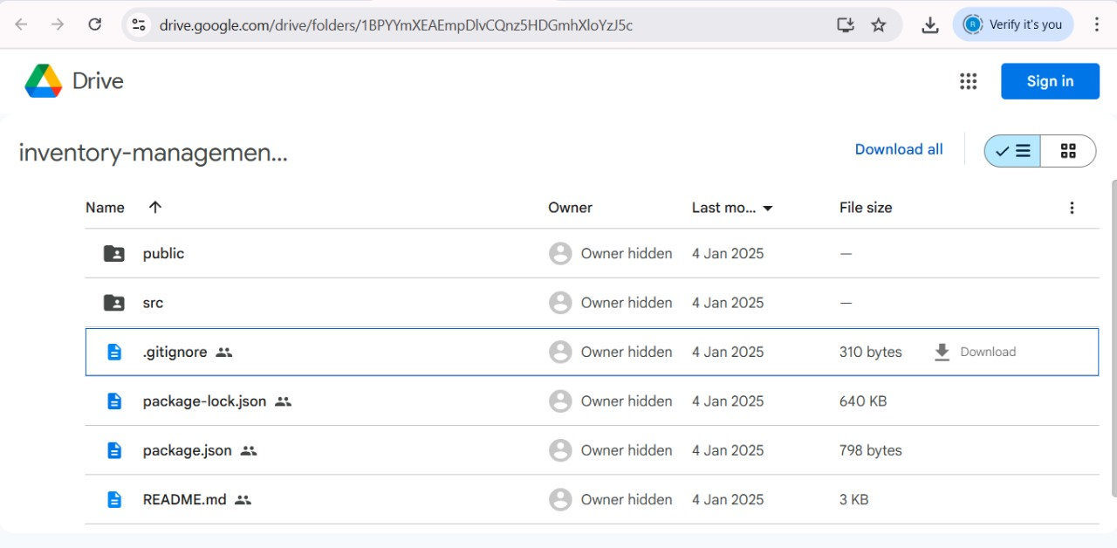

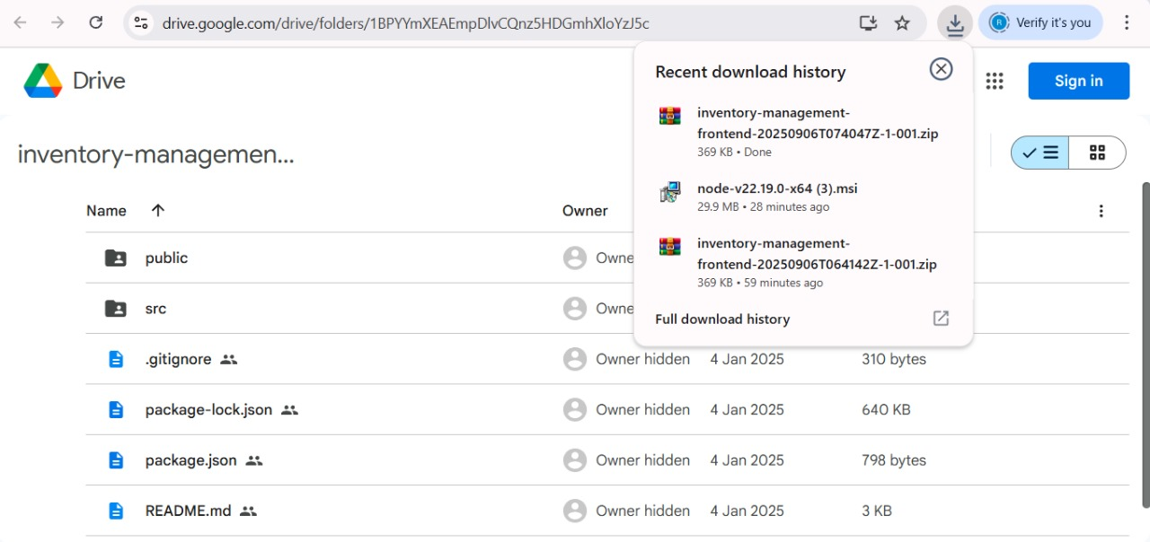

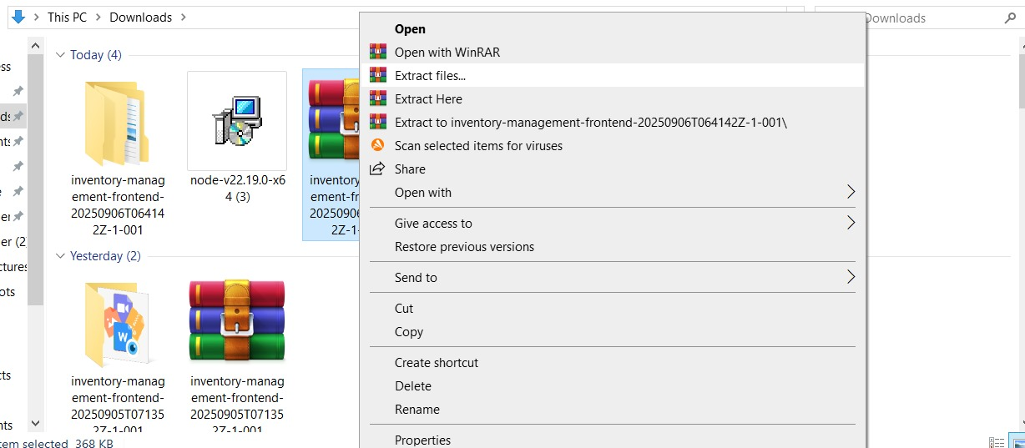

* Now open VS code and open the code folder from the extracted folder.

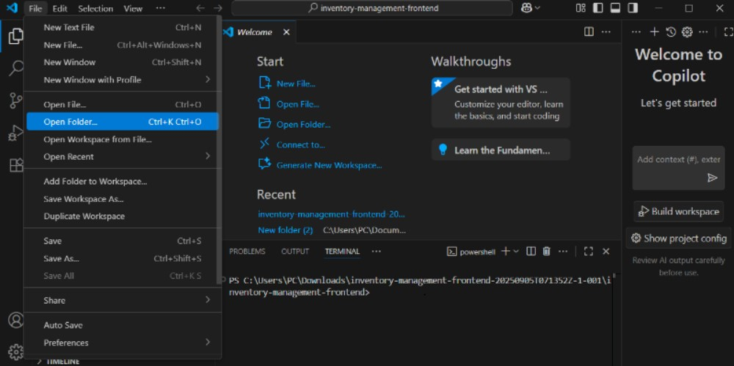

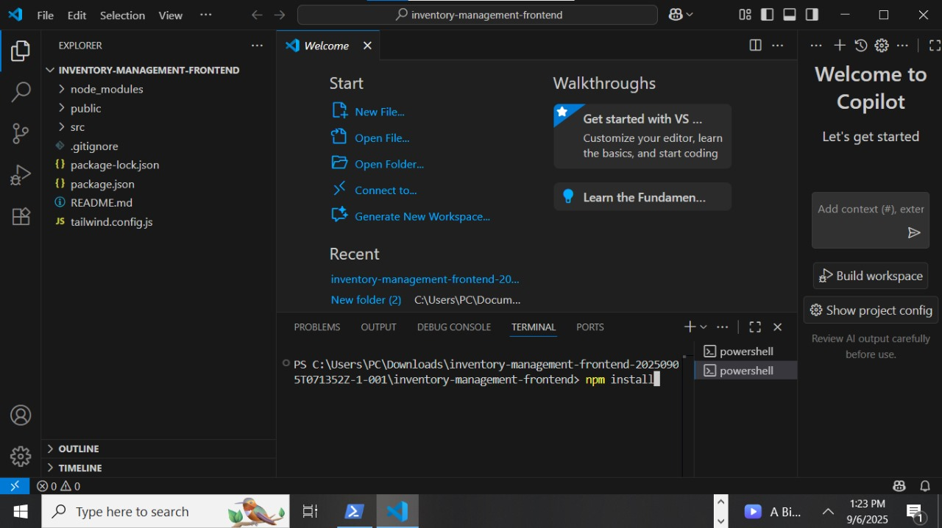

**Code for execution:**

import './App.css';

import {

createBrowserRouter,

RouterProvider,

} from "react-router-dom";

import AddProduct from './components/AddProduct';

import ProductCatalog from './components/Product/ProductCatalog';

import Layout from './Layout';

import Cart from './components/Cart/Cart';

import NotFound from './pages/NotFound';

import { CartProvider } from './context/CartContext';

import Inventory from './components/Inventory/Inventory';

import { InventoryProvider } from './context/InventoryContext';

import { SalesProvider } from './context/SalesContext';

import Sales from './components/Sales/Sales';

const router = createBrowserRouter([

{

element: (

<Layout />

),

children: [

{

path: "/",

element: <ProductCatalog />,

},

{

path: "/add-product",

element: <AddProduct />,

},

{

path: "/inventory",

element: <Inventory />,

},

{

path: "/cart",

element: <Cart />,

},

{

path: "/sales",

element: <Sales />,

},

{

path: "*",

element: <NotFound />,

},

]

}

])

const App = () => {

return (

<InventoryProvider>

<CartProvider>

<SalesProvider>

<RouterProvider router={router} />

</SalesProvider>

</CartProvider>

</InventoryProvider>

);

}

export default App

**OUTPUT:**

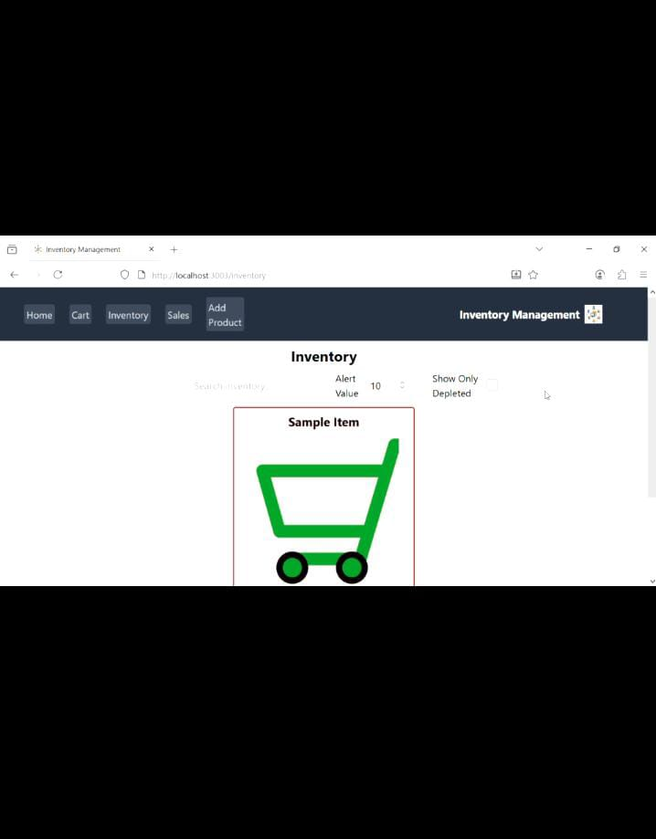

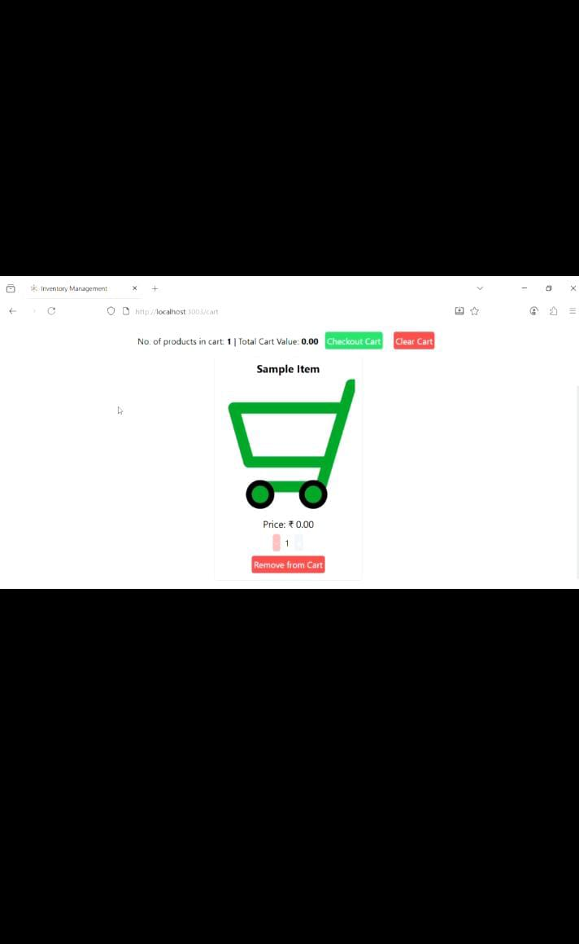

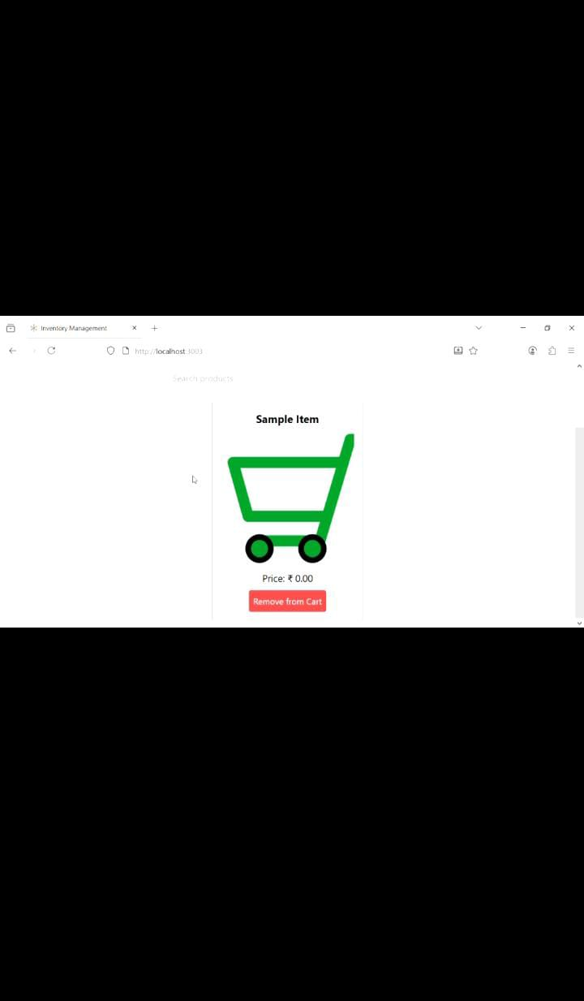

* RESULT:

Program has been created and executed successfully.